1. Go To –  
    <https://tortoisegit.org/download/>
2. Click on “**Windows**” button.

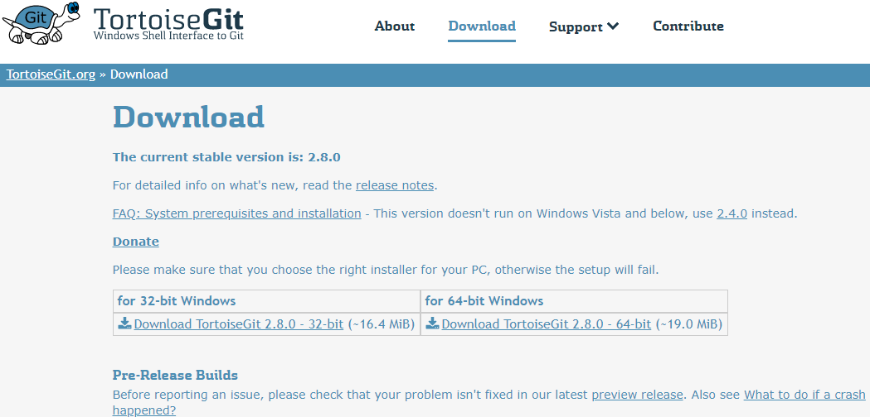

1. It will start downloading “**TortoiseGit-2.8.0.0-64bit.msi**” file. (version might be different).

Once the download is completed, **run** the downloaded **“.msi”** file –

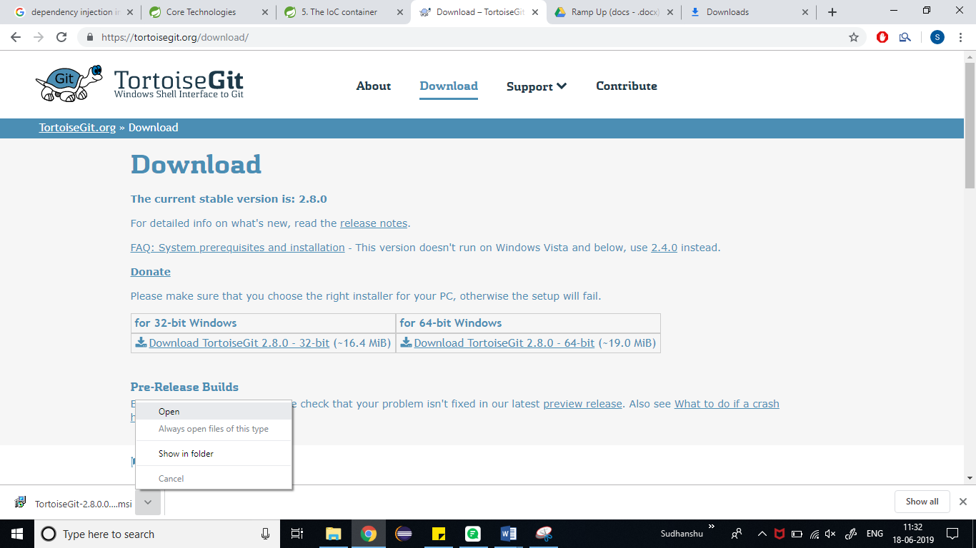

1. Click on **Next** –